**Question 01:**

**Code**

public class Main {  
 public static void main(String[] args) {  
  
 int speed = 75;  
 int dist = 3000;  
 int time = dist / speed;  
 System.*out*.println("The time taken to drive from Karachi to Lahore is:" + time);  
   
 }  
}

**Output**

**Question 02(a):**

**Code**

import java.util.Scanner;  
  
public class Main {  
 public static void main(String[] args) {  
  
 Scanner myObj = new Scanner(System.*in*);  
 System.*out*.println("Enter two doubles to multiply them");  
 double num1 = myObj.nextDouble();  
 double num2 = myObj.nextDouble();  
 double product = num1 * num2;  
 System.*out*.println("The numbers you entered were: " + num1 + " and " + num2 + " And there product is: " + product);  
  
 }  
}

**Output**

**Question 02(b):**

**Code**

import java.util.Scanner;  
  
public class Main {  
 public static void main(String[] args) {  
  
 Scanner myObj = new Scanner(System.*in*);  
 System.*out*.println("Enter the base of the triangle: ");  
 int base = myObj.nextInt();  
 System.*out*.println("Enter the height of the triangle: ");  
 int height = myObj.nextInt();  
 int area = base * height / 2;  
 System.*out*.println("The area of the triangle with base: " + base + " and height " + height + " is: " + area);  
  
 }  
}

**Output**

**Question 03:**

**Code**

import java.util.Scanner;  
  
public class Main {  
 public static void main(String[] args) {  
  
 Scanner myObj = new Scanner(System.*in*);  
 System.*out*.println("Welcome to the Calculator");  
 System.*out*.println("I will give you the sum, difference, product, division of the two numbers");  
 System.*out*.println("Please enter the first number");  
 double num1 = myObj.nextDouble();  
 System.*out*.println("Please enter the second number");  
 double num2 = myObj.nextDouble();  
 double sum = num1 + num2;  
 double difference = num1 - num2;  
 double product = num1 * num2;  
 double division = num1 / num2;  
 System.*out*.println("The sum of the entered numbers " + num1 + " and " + num2 + " is " + sum);  
 System.*out*.println("The difference of the entered numbers " + num1 + " and " + num2 + " is " + difference);  
 System.*out*.println("The product of the entered numbers " + num1 + " and " + num2 + " is " + product);  
 System.*out*.println("The division of the entered numbers " + num1 + " and " + num2 + " is " + division);  
  
 }  
}

**Output**

**Question 04:**

**Code**

import java.util.*;  
  
public class Main {  
 public static void main(String[] args) {  
  
 Scanner myObj = new Scanner(System.*in*);  
 System.*out*.println("WELCOME");  
 System.*out*.println("Please enter the value of a:");  
 double a = myObj.nextDouble();  
 System.*out*.println("Please enter the value of b:");  
 double b = myObj.nextDouble();  
 System.*out*.println("Please enter the value of c:");  
 double c = myObj.nextDouble();  
 double d = b * b;  
 double x1 = -b + Math.*sqrt*(d - 4.0 * a * c);  
 x1 /= 2.0 * a;  
 double x2 = -b - Math.*sqrt*(d - 4.0 * a * c);  
 x2 /= 2.0 * a;  
 System.*out*.println("The solutions are :" + x1 + " and " + x2);  
   
 }  
}

**Output**

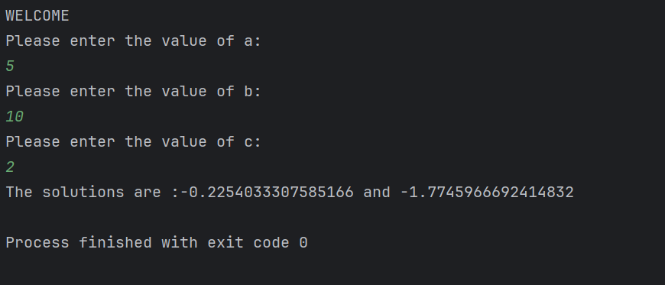

**Question 05:**

**Code**

import java.util.*;  
  
public class Main {  
 public static void main(String[] args) {  
  
 Scanner myObj = new Scanner(System.*in*);  
 System.*out*.println("Enter the first number: ");  
 float a = myObj.nextFloat();  
 System.*out*.println("Enter the second number: ");  
 float b = myObj.nextFloat();  
 System.*out*.println("Enter the third number: ");  
 float c = myObj.nextFloat();  
 float sum = a + b + c;  
 System.*out*.println("The sum of the numbers " + a + " , " + b + " and " + c + " is: " + sum);  
 float average = (a + b + c) / 3.0F;  
 System.*out*.println("The average of the numbers " + a + " , " + b + " and " + c + " is: " + average);  
 float product = a * b * c;  
 System.*out*.println("The product of the numbers " + a + " , " + b + " and " + c + " is: " + product);  
  
 }  
}

**Output**

**Question 06:**

**Code**

import java.util.*;  
  
public class Main {  
 public static void main(String[] args) {  
  
 Scanner myObj = new Scanner(System.*in*);  
 System.*out*.println("Please enter the radius of the circle: ");  
 double radius = myObj.nextDouble();  
 double pi = 3.14159;  
 double diameter = 2.0 * radius;  
 double area = pi * radius * radius;  
 double circumference = 2.0 * pi * radius;  
 System.*out*.println("The diameter of the circle with radius " + radius + " is " + diameter);  
 System.*out*.println("The area of the circle with radius " + radius + " is " + area);  
 System.*out*.println("The circumference of the circle with radius " + radius + " is " + circumference);  
  
 }  
}

**Output**

**Question 07:**

**Code**

import java.util.*;  
  
public class Main {  
 public static void main(String[] args) {  
 Scanner myObj = new Scanner(System.*in*);  
 System.*out*.println("WELCOME");  
 System.*out*.println("Please enter your name: ");  
 String name = myObj.nextLine();  
 System.*out*.println("Now enter your roll number: ");  
 String rollnumber = myObj.nextLine();  
 System.*out*.println("Enter the name of your 1st course: ");  
 String course1 = myObj.nextLine();  
 System.*out*.println("Enter the name of your 2nd course: ");  
 String course2 = myObj.nextLine();  
  
 System.*out*.println("Name: " + name);  
 System.*out*.println("Roll Number: " + rollnumber);  
 System.*out*.println(""+course1);  
 System.*out*.println(""+course2);  
  
 }  
}

**Output**

**Question 08:**

**Code**

import java.util.*;  
  
public class Main {  
 public static void main(String[] args) {  
 Scanner myObj=new Scanner(System.*in*);  
 System.*out*.println("Please enter the size of the array: ");  
 int size=myObj.nextInt();  
 int[] array=new int[size];  
  
 System.*out*.println("Please enter the elements of the array: ");  
 for (int i=0; i<size; i++){  
 array[i]=myObj.nextInt();  
 }  
  
 int max=array[0];  
 int min=array[0];  
  
 for (int i=1; i<size; i++){  
 if (max<array[i]){  
 max=array[i];  
 }  
 if (min>array[i]){  
 min=array[i];  
 }  
 }  
 System.*out*.println("The largest/maximum number is " + max);  
 System.*out*.println("The smallest/minimum number is " + min);  
  
 }  
}

**Output**

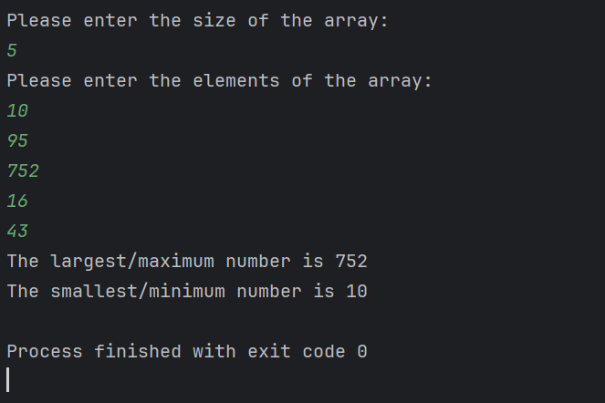

**Question 09:**

**Code**

import java.util.*;  
  
public class Main {  
 public static void main(String[] args) {  
  
 System.*out*.println("WELCOME TO TIC-TAC TOE!");  
 char[][]board={  
 {'X','O','X'},  
 {'O','X','O'},  
 {'O','O','X'}  
 };  
 if(board[0][0]=='X'){  
 if (board[0][0]==board[0][1] && board[0][0]==board[0][2] ||  
 board[0][0]==board[1][0] && board[0][0]==board[2][0] ||  
 board[0][0]==board[1][1] && board[0][0]==board[2][2]){  
 System.*out*.println("Player 'X' WINS!");  
 }  
 }  
 else if(board[0][0]=='O'){  
 if(board[0][0]==board[0][1] && board[0][0]==board[0][2] ||  
 board[0][0]==board[1][0] && board[0][0]==board[2][0] ||  
 board[0][0]==board[1][1] && board[0][0]==board[2][2]){  
 System.*out*.println("Player 'O' WINS!");  
 }  
 }  
 else{  
 System.*out*.println("Its a DRAW!");  
 }  
  
 }  
}

**Output**

**Question 10:**

**Code**

import java.util.*;  
  
public class Main {  
 public static void main(String[] args) {  
  
 ArrayList<String> namesList = new ArrayList<>();  
 Scanner myObj = new Scanner(System.*in*);  
 System.*out*.println("Enter the number of names: ");  
 int n = myObj.nextInt();  
  
 myObj.nextLine();  
  
 for (int i=0; i<n; i++) {  
 System.*out*.println("Enter the name " + (i + 1) + ": ");  
 String name = myObj.nextLine();  
 namesList.add(name);  
 }  
 System.*out*.println("Names in reverse order:");  
 for (int i= namesList.size()-1; i>=0; i--) {  
 System.*out*.println(namesList.get(i));  
 }  
  
 }  
}

**Output**

